Initial page:
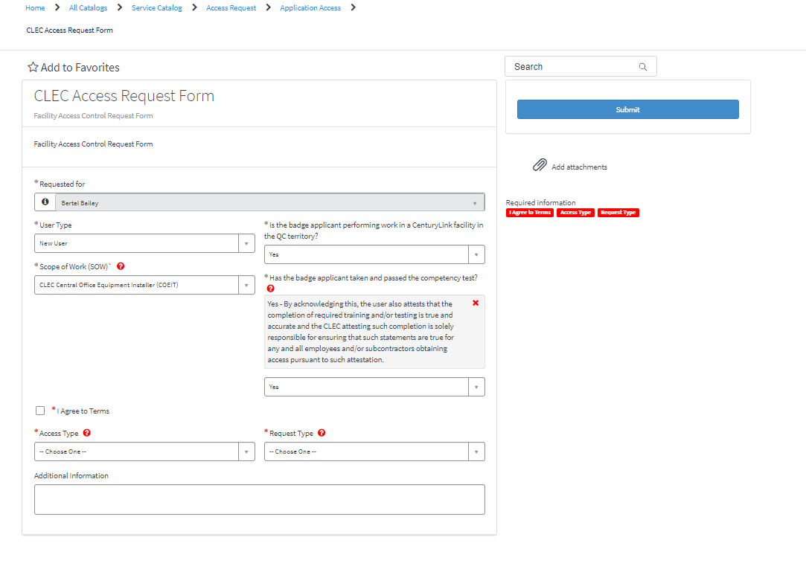
- If you choose *User Type “New User”
    - and *Scope of work More information “CLEC Central Office Equipment Installer (COEIT)”
    - If you choose CLEC Central Office Technician go to step 4
1a. If you choose *User Type “Existing User” go to step 5
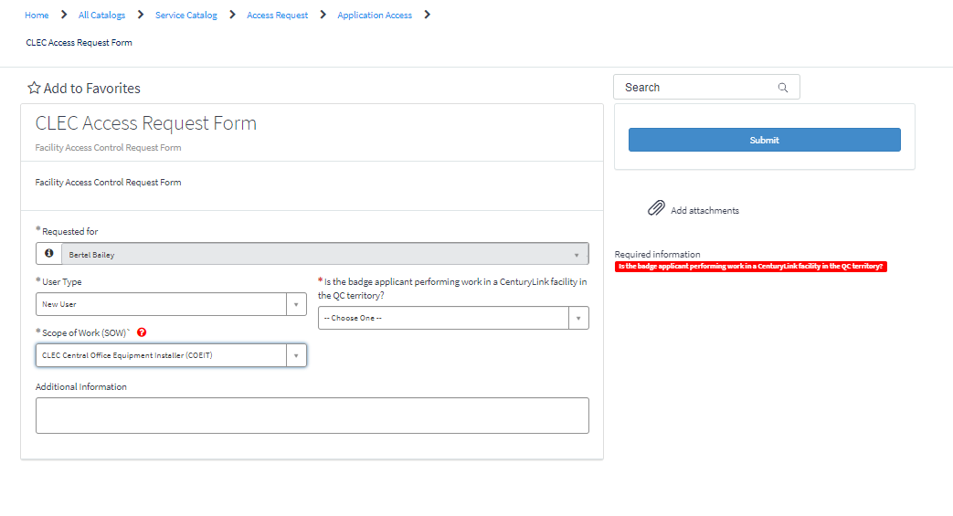

- If you choose Yes in “Is the badge applicant performing work in a CenturyLink facility in the QC territory?
  - If you choose “No” fill out the Additional Information and Submit

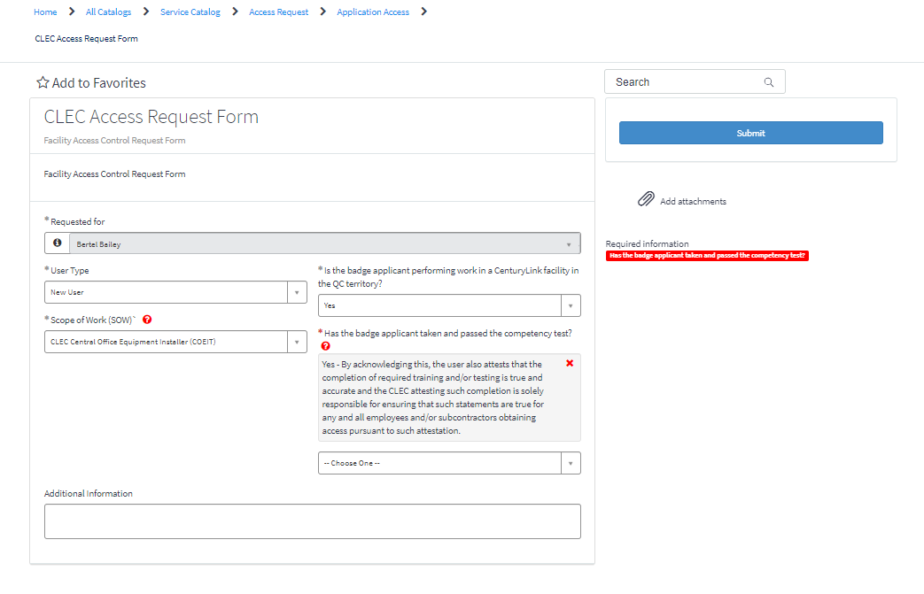

- If you choose yes on “Has the badge applicant taken and passed the competency test?”
  - If you choose “NO” complete the CLEC/CLEC Subcontractor Inside Plant (ISP) Competency Requirements and Testing on Technical Standards
prior to being issued an access badge.

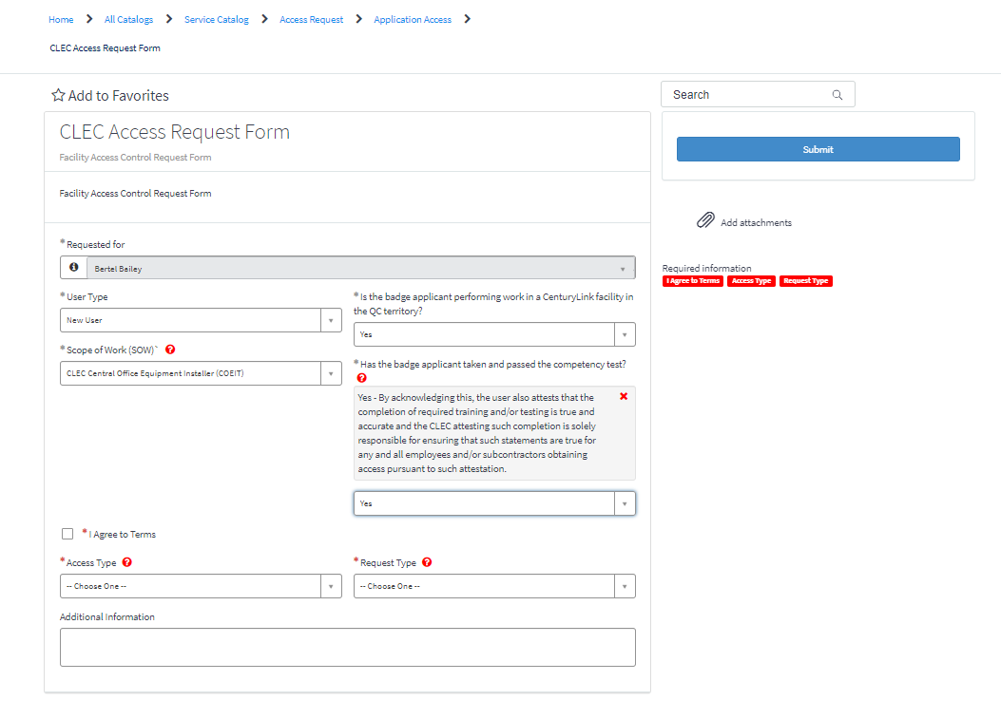

If you click on “I Agree to Terms” :
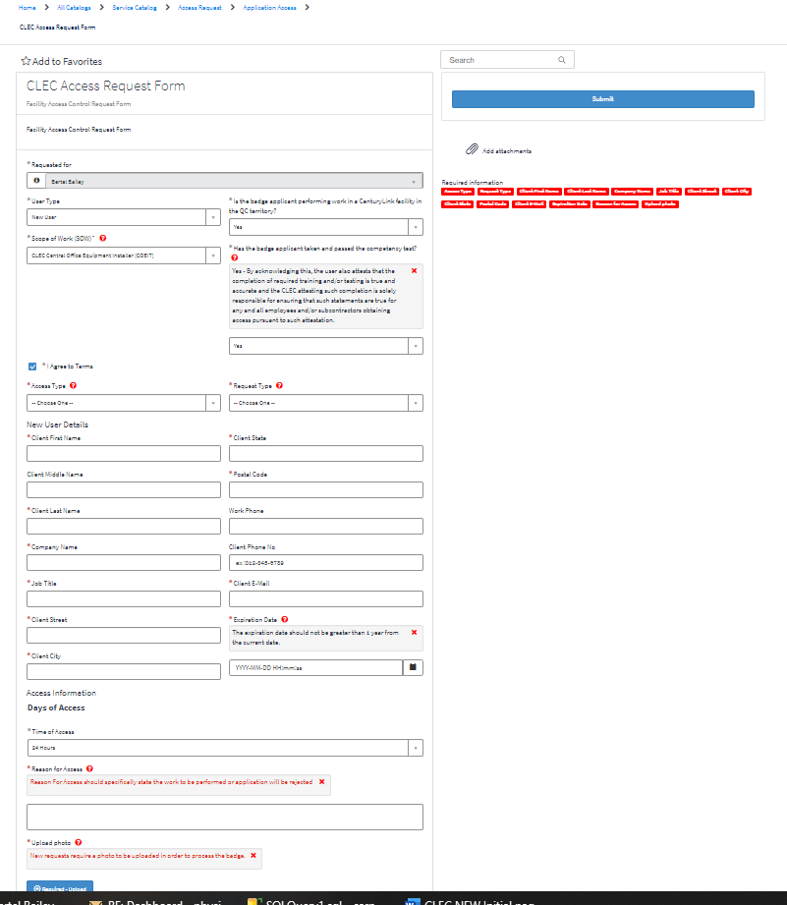

Fill out all information and submit request in top right corner.
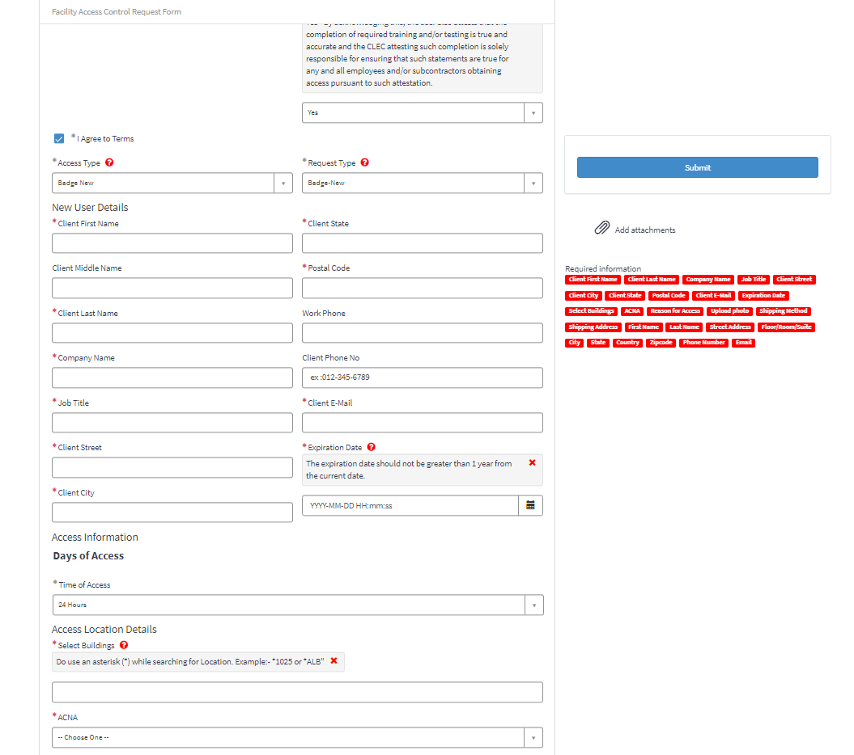
____________________ END ____________________
- Fill out and submit the form.
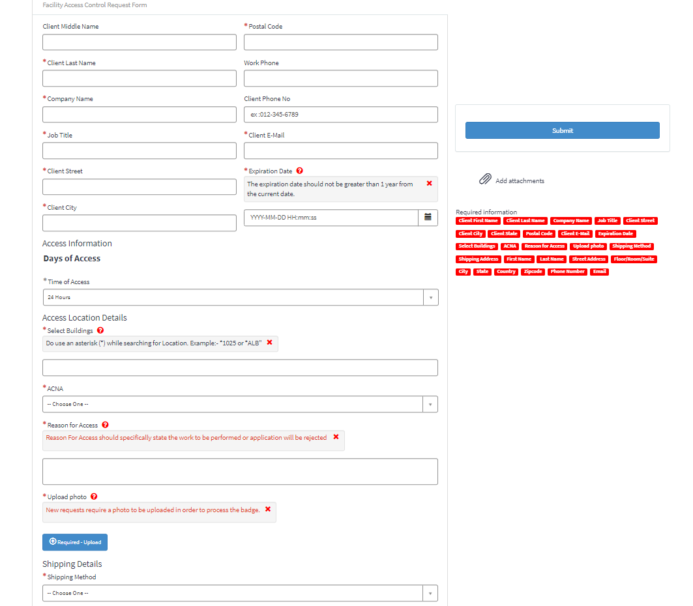

__________________ END___________________

- Existing User
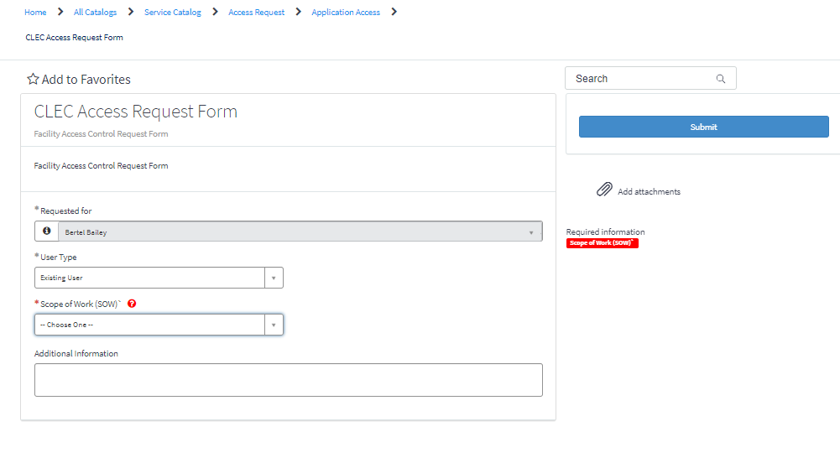
- If you choose *User Type “Existing User”
    - and *Scope of work More information “CLEC Central Office Equipment Installer (COEIT)”
    - If you choose CLEC Central Office Technician go to step 9
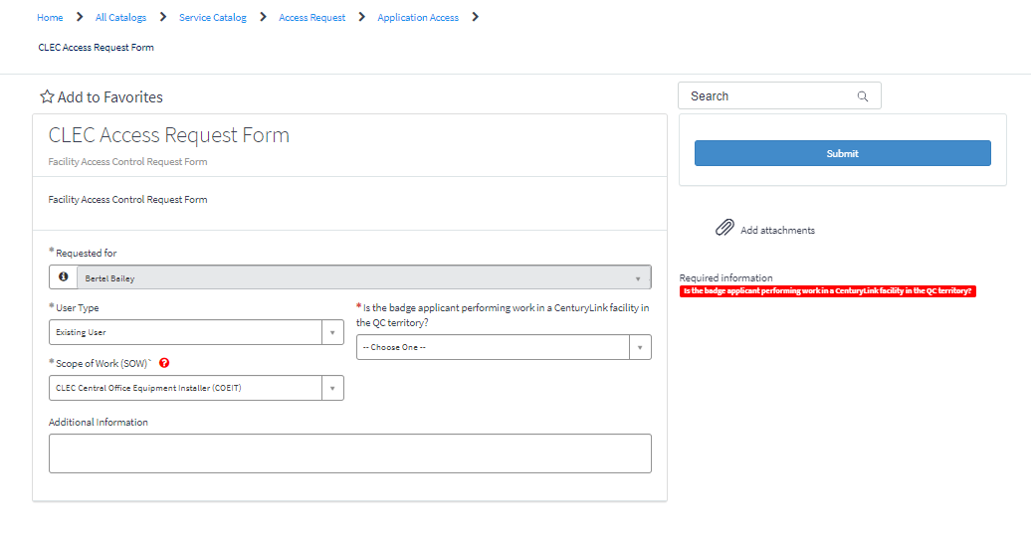
- If you choose Yes in “Is the badge applicant performing work in a CenturyLink facility in the QC territory?
    - If you choose “No” Then fill out the Additional Information and Submit

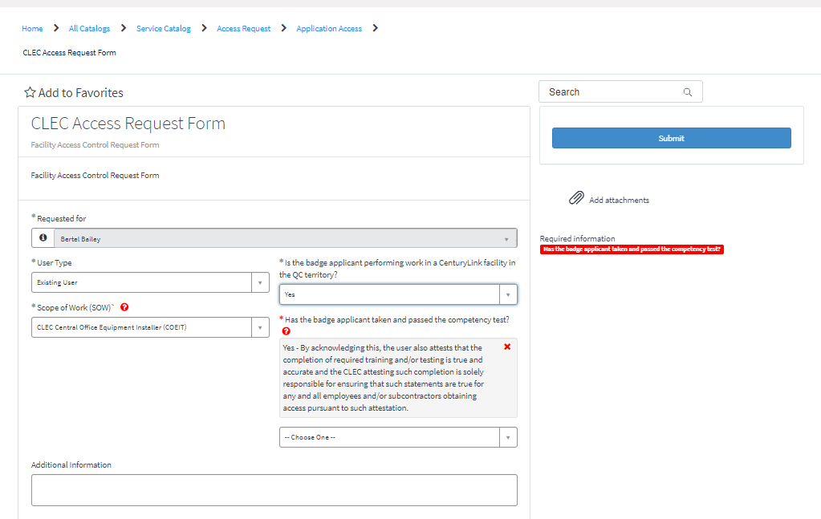

If you choose “Yes” on “Has the badge applicant taken and passed the competency test?”
  - If you choose “NO” complete the CLEC/CLEC Subcontractor Inside Plant (ISP) Competency Requirements and Testing on Technical Standards
prior to being issued an access badge.

If you click, I Agree to Terms:

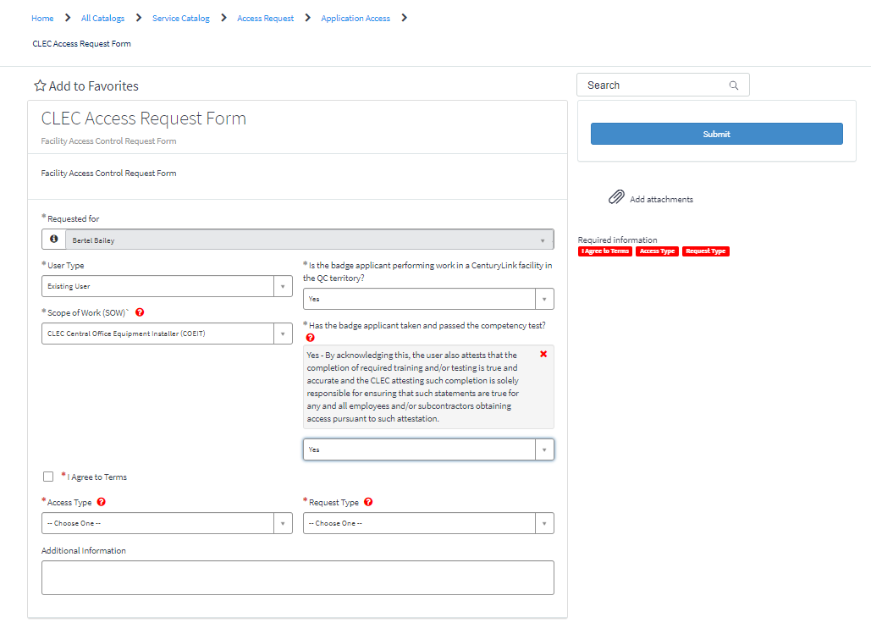

Fill out forms and Submit in top right corner.

_______________________END________________________

- Fill out forms and Submit in top right corner.
